Chapter 9, Solution 13.

(a)

(b) 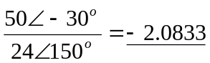 = –2.083

(c) (2+j3)(8-j5) –(-4) = 35 +j14

